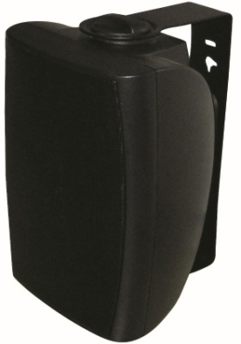
8" Two Way Wall Mount Speaker (60W)
FWS-560
Feature:
- Commercial PA system wall mount speaker with transformer
- Ideal for school, office, hotel and airport background music system
- Economy rang fashion wall mount cabinet loudspeaker
- Rated power output 7.5W-15W-30W-60W at 100V
- 8" woofer and 2” tweeter two way speaker units
- Line input 100V or 70V
- With 100V & low impedance 8Ω power selector
- ABS enclosure, metal grille in black
- Quick installation by supplied stainless mounting bracket
- FWS-560W as option of white finish

Specification:
Model | FWS-560
Description | 8” Two Way Wall Mount Speaker
Rated Power Output | 7.5W-15W-30W-60W
Line Input | 100V or 70V
Frequency Response | 40-20KHz
SPL(@1W/m) | 92dB
Speaker Unit | 8” woofer and 2” tweeter two way speaker units
Dimension | 417 (W)×289(D)×255(H)mm
Material | ABS enclosure and metal grille in black
Mounting Way | Quick installation by supplied stainless mounting bracket
Weight | 6.6kg
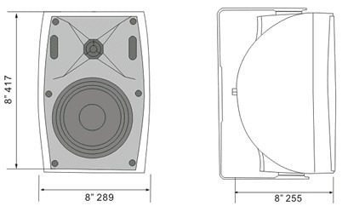
Side View & Dimensions:
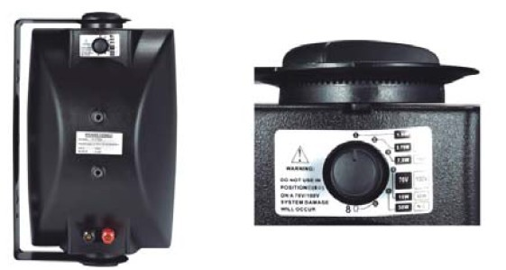

Frequency Response VS SPL Diagram:
